COVID-19 Vaccine Management System
Software Requirements Specification

Version 1.0



Group Id: S2102A3CF0
Supervisor Name: Hina Ishaq

Revision History
Date (dd/mm/yyyy) | Version | Description | Author
24/05/2021 | 1.0 | This project is all about managing the successful distribution of COVID-19 Vaccines nationwide by a web-based interface. This system will provide users and admins specific interfaces to interact with it. This is going to be the first version i.e. 1.0 of the system, and this document will include details about followings:  - Scope of the project  - Functional and non-functional requirements of the project  - Use case diagrams  - Usage scenarios  - Adopted methodology  - Work plan | Hamza Ashraf (BS170400637)

Table of Contents

- Scope (of the project)
- Functional Requirements Non Functional requirements
- Use Case Diagram
- Usage Scenarios
- Adopted Methodology
- Work Plan (Use MS Project to create Schedule/Work Plan)

SRS Document

Scope of Project:

“COVID-19 Vaccine Management System” is an appointment scheduling system to facilitate the residents with scheduling their COVID-19 vaccine appointments. It will provide on hand information about current COVID-19 situation. The aim of this website is to manage mass vaccination, including vaccine distribution and administration. The system will be designed to provide real- time access to vaccine distribution centers. The system will also reduce the manual efforts and cost required for paper work. So, it will benefit the both public and government.

This system will contain the information regarding COVID-19 virus and how it spreads and it will also provide preventive measure that individuals can take in their homes and workplaces. Said system will provide complete details of COVID-19 cases including active cases, recovered, critical. These cases will be sub-divided on regional basis and filters can be applied to analyze cases data to manage vaccines distribution properly.

Patients can visit this website on any gadgets which supports a web browser. Patients can either signup through this website or can schedule their appointment to get vaccinated after registration. In both cases an appointment will be schedule and their specified vaccination center and time slot will be locked. So, that they do not have any troubles while getting vaccinated.

Their will be specific dashboards available for users and admins through which they can interact with the system. Admins can schedule appointments of patients, add new user/admins, accept or reject appointment of a patient, add vaccination centers, add available time slots and update information being shown on website regarding cases. Admins will also have access to data of patients vaccinated.

This system will also contain information about vaccines available in the market and provide comprehensive comparison of these by mentioning their pros and cons.

Functional and non Functional Requirements:

Functional requirements:
Functional requirements of the system include followings:
- Users can view the details of vaccination, vaccination procedures and related information without registration.
- Users can register themselves to get appointments.
- Users can schedule appointments online.
- Users can also give feedback about the services provided.
- User can also register complaint about any suspicious activity or any misconduct.
- Registration and Login interface of the main administrator.
- The main administrator can add any other person as admin.
- Admin can add/remove categories or edit existing categories.
- Admin can insert, delete, view and update records.
- Admin can cancel the appointment.
- Logout interface to logout of system.

Non-functional requirements:
This system has following non-functional requirements:
- Availability: The system should be designed by keeping the concepts of high availability. Because this system will be providing services to general public and system might breakdown if a lot of users connect at the same time. So, the system should always be online to provide core services.
- Performance: Application should be designed in such a way that it uses less computing resources so that it could be deployed in a cos-effective way.
- Usability: Interface should be clear and concise and everything should be categorized properly so that users can interact with the system without having to get any technical training.
- Security: As general public will be using this system and their login credentials will be saved in database. System should provide secure ways to interact with the system and passwords should also be stored in encrypted form so that, user’s privacy doesn’t compromise in any case.

Use Case Diagram(s):

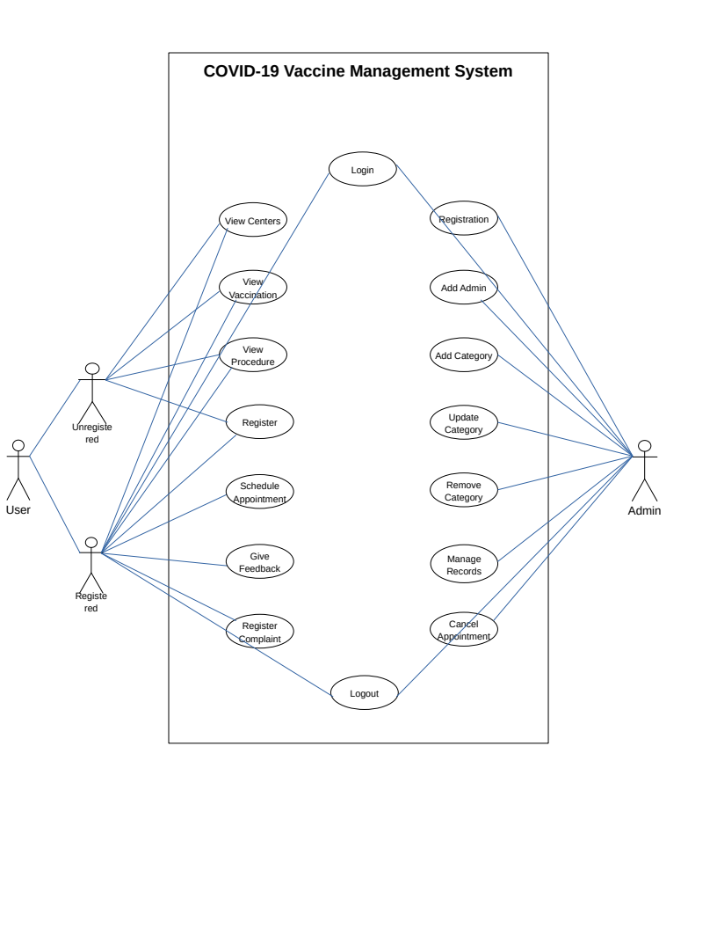

Usage Scenarios:

Usage Scenario 1
Use Case Title | View Vaccination Centers
User Case Id | Case_001
Actions | - User types in the URL in the browser and get in to homepage  - User sees vaccination centers in navigation and clicks it  - Vaccination centers page opens with all the available vaccination centers  - User can apply filters i.e. city  - On applying filters vaccination centers with filter criteria will be shown  - User can click on a center to view details about center
Description | Check all available centers for COVID-19 vaccination
Alternative Paths | Scroll down and click a center to display detailed information
Preconditions | Web browser with a working internet connection
Post-conditions | User finds a suitable vaccination center
Author | Hamza Ashraf (BS170400637)
Exceptions | No centers available

Usage Scenario 2
Use Case Title | View Vaccinations
User Case Id | Case_002
Actions | - User types in the URL in the browser and gets to the homepage  - User sees vaccinations in navigation and clicks it  - Vaccinations page opens with all the available vaccinations  - User can click on a vaccination to view details about vaccination
Description | Check all available vaccinations of COVID-19
Alternative Paths | Scroll down and click a vaccination to display detailed information
Preconditions | Web browser with a working internet connection
Post-conditions | User finds required details about a vaccination
Author | Hamza Ashraf (BS170400637)
Exceptions | No vaccinations available

Usage Scenario 3
Use Case Title | View Procedure To Get Vaccinated
User Case Id | Case_003
Actions | - User types in the URL in the browser and get in to homepage  - User sees procedure in navigation and clicks it  - Vaccination procedure page opens with a list of procedures to get vaccinated
Description | Check procedure to get vaccination
Alternative Paths | User can get to this page from vaccination appointment page
Preconditions | Web browser with a working internet connection
Post-conditions | User finds complete procedure to get vaccinated
Author | Hamza Ashraf (BS170400637)
Exceptions | There can be a different procedure for physically challenged people

Usage Scenario 4
Use Case Title | User Registration
User Case Id | Case_004
Actions | - User types in the URL in the browser and get in to homepage  - User sees registration in navigation and clicks it  - Registration page opens with a registration form  - User types in details in input fields in the registration form and click register  - A success message is shown to user for registration and a link to login page is shown
Description | Get registered as a user
Alternative Paths | User clicks already registered login now to redirect to login page
Preconditions | Web browser with a working internet connection
Post-conditions | User gets registered
Author | Hamza Ashraf (BS170400637)
Exceptions | - Empty or invalid input values  - User already registered

Usage Scenario 5
Use Case Title | User Login
User Case Id | Case_005
Actions | - User types in the URL in the browser and get in to homepage  - User sees login in navigation and clicks it  - Login page opens with a login form  - User fill in the form and clicks login to login in to the system
Description | Login to the system to use restricted options
Alternative Paths | User can get to this page from sign up page
Preconditions | Web browser with a working internet connection
Post-conditions | User gets logged in to the system
Author | Hamza Ashraf (BS170400637)
Exceptions | Invalid credentials

Usage Scenario 6
Use Case Title | Schedule Appointment
User Case Id | Case_006
Actions | - User types in the URL in the browser and get in to homepage  - User login to the system  - User click Schedule an appointment and gets a page with appointment form  - User selects city, center, and vaccination type to make an appointment and clicks confirm
Description | Make an appointment to get vaccinated
Alternative Paths | Use can get to this page through dashboard
Preconditions | Web browser with a working internet connection
Post-conditions | User gets a successful appointment message
Author | Hamza Ashraf (BS170400637)
Exceptions | Appointment already scheduled

Usage Scenario 7
Use Case Title | Give Feedback
User Case Id | Case_007
Actions | - User types in the URL in the browser and get in to homepage  - User logins to the system and opens dashboard  - There is an option for feedback  - After clicking feedback option a page with form will be shown  - User types in his message and submits feedback
Description | Give feedback of services after getting vaccinated
Alternative Paths | After scrolling down to footer user can open feedback form
Preconditions | - Web browser with a working internet connection  - Registered user and got vaccinated
Post-conditions | User submits its feedback for improvements
Author | Hamza Ashraf (BS170400637)
Exceptions | User is not registered

Usage Scenario 8
Use Case Title | Register a Complaint
User Case Id | Case_008
Actions | - User types in the URL in the browser and get in to homepage  - User logins to the system and opens dashboard  - There is an option to register a complaint  - On clicking register a complaint option a form is shown  - User selects appropriate values in fields and types in his message and submits his complaint
Description | Register a complaint about something wrong
Alternative Paths | After scrolling down to footer user can open complaint form
Preconditions | - Web browser with a working internet connection  - Registered user
Post-conditions | User submits its complaint for an action to be taken
Author | Hamza Ashraf (BS170400637)
Exceptions | User is not registered

Usage Scenario 9
Use Case Title | User Logout
User Case Id | Case_009
Actions | - User types in the URL in the browser and get in to homepage  - User logins to the system and after being logged in it can click on profile icon  - Profile icon will show an option to logout  - After clicking logout a dialog with confirmation message will be shown  - After confirming user logout of the system
Description | User logout of the system and discontinue using services
Alternative Paths | Go to dashboard and click logout to terminate session
Preconditions | - Web browser with a working internet connection  - User already logged in
Post-conditions | User session is terminated and is no longer able to use services unless it logins again
Author | Hamza Ashraf (BS170400637)
Exceptions | User already logged out

Usage Scenario 10
Use Case Title | Administrator Registration
User Case Id | Case_010
Actions | - Admin logins to system as admin privileges  - Admin opens its dashboard and there is an option to manage administrators  - On clicking manage administrator admin can open an option to add administrator  - Admin needs to provide user name to make administrator  - On clicking add it will confirm password and administrator will be added in the system
Description | Add administrators of the system
Alternative Paths | Type in a specific URL to open a link to register as a administrator with a certain credentials to be provided
Preconditions | - Web browser with a working internet connection  - Logged in as a admin user
Post-conditions | Admin user is added
Author | Hamza Ashraf (BS170400637)
Exceptions | Already admin

Usage Scenario 11
Use Case Title | Cancel An Appointment
User Case Id | Case_011
Actions | - Admin logins to the system with admin privileges  - After loading admin dashboard admin can view all appointments  - Admin can select any appointment from the list and can click cancel button  - After clicking cancel a confirmation dialog will be opened  - On confirming the appointment gets canceled
Description | Cancel appointment of a user
Alternative Paths | Admin can view requests for appointments cancellation and it can accept a request to cancel an appointment
Preconditions | - Web browser with a working internet connection  - Login as a admin user
Post-conditions | Appointment gets canceled
Author | Hamza Ashraf (BS170400637)
Exceptions | Appointment is already completed

Usage Scenario 12
Use Case Title | Manage Records
User Case Id | Case_012
Actions | - Admin logins to the system and opens dashboard  - Admin can open any link from navigation i.e. Vaccination centers, vaccination categories, cities, appointments  - Admin can view any data from these categories after clicking  - Admin can open any record from these categories and can click buttons to edit or delete any record
Description | Insert, update and delete records
Alternative Paths | Admin can find options to edit and delete records on their specific pages
Preconditions | - Web browser with a working internet connection  - Logged in as a admin
Post-conditions | Records get inserted, updated or deleted
Author | Hamza Ashraf (BS170400637)
Exceptions | Record not found

Adopted Methodology

Some of the commonly used software development methodologies are listed below:
- Agile
- Lean
- Waterfall
- Iterative
- Spiral
- DevOps
There are a lot of software development methodologies available but for this project I will be using a combination of Waterfall and Spiral.

1. Waterfall methodology
Waterfall model is widely considered the oldest of the structured SDLC methodologies. It’s also a very straightforward approach: finish one phase, then move on to the next. Each stage relies on information from the previous stage and there is no going back. This model is also known as linear sequential model.
The waterfall model is a documentation-driven model. Therefore, it generates complete and comprehensive documentation and hence makes the maintenance task much easier. However, it suffers from facts that the client feedback is received when the product is deployed and any omission in the requirement specifications is not discovered until the product is shipped to the client after its completion. However if requirements are already known this model is preferred for such system. As in out case we know our requirements of the project very clearly.

2. Spiral methodology
One of the most flexible SDLC methodologies, the Spiral model takes a cue from the Iterative model and its repetition; the project passes through four phases (planning, risk analysis, engineering and evaluation) over and over in a “spiral” until completed, allowing for multiple rounds of refinement.
The Spiral model is typically used for large projects. It enables development teams to build a highly customized product, and incorporate user feedback early on in the project. Another benefit of this SDLC model is risk management. Each iteration starts by looking ahead to potential risks, and figuring out how best to avoid or mitigate them.
Because our system is going to be used by general public and it is going to be refined over time so it is better for us to use a Spiral model. By implementing spiral we can overcome the limitations like rigidity of Waterfall model, if it would have been used in isolation.

Requirements
Planning
Software requirement
Work plan
Analysis
Risk analysis
Cost effectiveness
With less risk
Deliver project with specific requirement otherwise recycle for further evaluation
Designing coding
Testing

Design
Coding
Testing
Acceptance
Client evaluation
Development
In VU model
Each phase report back

Benefits of using this methodology:
- We can follow project sequentially. i.e. from one stage to next.
- This model is easy to understand and use
- We will be getting specific product after each stage.
- By using combination of these two models we can limit our risk of project failure.
- If at any stage, we need to add some additional functionalities, this model will make it possible.

Work Plan (Use MS Project to create Schedule/Work Plan)

